**Perspective Projection**

Method for generating a view of a three-dimensional scene by **projecting points to the display plane along converging paths**.

This causes **objects farther from the viewing position to be displayed smaller** than objects of the same size that are nearer to the viewing position.

In a perspective projection,parallel lines in a scene that are not parallel to the display plane are **projected into converging lines.**

Scenes displayed using perspective projections **appear more realistic**, since this is the way that eyes and camera lens form images.

In the perspective projection view, parallel lines appear to converge to a distant point in the background, and distant objects appear smaller than objects closer to the viewing position.

To obtain a perspective projection of a three-dimensional object, transform points along projection lines that meet at the **projection reference point**.

Suppose the perspective reference point is set at position ***zprp*** along the ***zv,*** axis, and the view plane is placed at zvp .

Equations describing coordinate positions along this perspective projection line in parametric form as

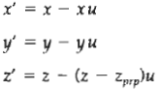

Parameter ‘u’ takes values from *0* to 1, and coordinate position *(x',* y'**,** z') represents any point along the projection line.

When u = *0,* we are at position P = (x,y, z)

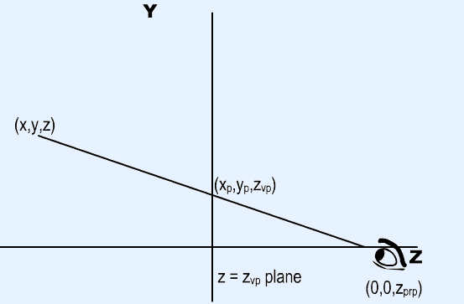

At the other end of the line, ***u*** = 1 and we have the projection reference point coordinates (0,0*, zprp*)On the view plane, *z*' = *zvp ,* and we can solve the z' equation for parameter ***u*** at this position along the projection line:



Substituting this value of ***u*** into the equations for ***x'*** and y', **we** obtain the perspective transformation equations

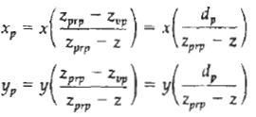

where, dp = **zprp** - zvp is the distance of the view plane from the projection reference point.

Using a three-dimensional homogeneous-coordinate representation, we can write the perspective projection transformation in matrix form as

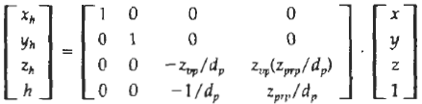

In this representation, the homogeneous factor is



and the projection coordinates on the view plane are calculated from the homogeneous coordinates as



where the original z-coordinate value would be retained in projection coordinates for visible-surface and other depth processing.

In general, the projection reference point does not have to be along the zv axis.

There are a number of special cases for the perspective transformation equations.

If the view plane is taken to be the ***uv*** plane, then zvp= 0 and the projection coordinates are

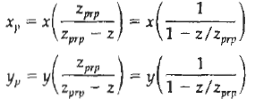

And, in **some** graphics packages, the projection reference point is always taken to be at the viewing-coordinate origin. In this case, zprp = **0** and the projection coordinates on the viewing plane are

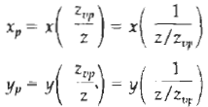

When a three-dimensional object is projected onto a view plane using perspective transformation equations, any set of parallel lines in the object that are not parallel to the plane are projected into converging lines.

Parallel Lines that are parallel to the view plane will be projected as parallel lines.

The point at which a set of projected parallel lines appears to converge is called a vanishing point.

**Each** such set of projected parallel lines will have a separate vanishing point; and in general, a scene can have any number of vanishing points, depending on how many sets of parallel lines there are in the scene.

The vanishing point for any set of lines that are parallel to one of the principal axes of an object is referred to as a principal vanishing point.

The number of principal vanishing points (one, two, or three) are controlled with the orientation of the projection plane, and perspective projections are accordingly classified as one-point, two-point, or **three-point** projections.

The number of principal vanishing points in a projection is determined by the number of principal axes intersecting the view plane.

